WAYNE COUNTY FAMILY & CHILDREN FIRST COUNCIL
Agenda
Wooster City Hall- Council Chambers

February 5, 2024 9:35 AM
- Call to Order - Cascarelli
- Welcome and Introductions

- Consent Agenda— Cascarelli- Action Required

- December 2023 Minutes and Committee Reports – Cascarelli – Action Required

- February financials- Cascarelli- Action Required

- Old Business

- New Business
  - Strategic Plan- Cascarelli
  - Director Evaluation- Stika

- Presentation: Early Intervention-- Baumgartner

- Council Priorities: Updates

- Family Engagement …………………………………………………… FCFC Family Advisory

- Reduce the number of kids and time spent out of home:
  - Diversion Team—FCFC
  - Asha Step-Down & Respite House—FCFC
  - CSB, CANS, Crisis Stabilization Center, FDTC, Home Based Treatment, MRSS
- Expand Capacity for Service Coordination/Wraparound:
  - FCSS – Service Coordination—FCFC/Anazao
  - WISE Wraparound—Catholic Charities
  - Family Stabilization & Home Transition Coordination—Anazao
  - Early Intervention—Wayne DD/FCFC
- Increase Youth Assets:
  - Wayne Resiliency Network—MHRB
  - Youth Mentors-- OHuddle, Catholic Charities/Juvenile Court, Anazao
  - Public Libraries—Wayne County and Orrville
  - OSU Extension
  - School initiatives, afterschool programs, art and music, sports, faith community, employment
  - Parenting—Triple P, CSB, Home visiting, Anazao
- Keep our families Substance Free:
- FDTC, Health Department, OneEighty, Coalitions, Hospitals, MHRB
- Adjourn

NEXT FULL COUNCIL MEETING: April 1, 2024
Chalet at Freedlander Park, Wooster

Acronyms and Definitions

CANS Child Adolescent Strength and Needs Assessment
CME Care Management Entity (under OhioRise Medicaid)
FCSS Family Community Services and Supports grant that funds Service Coordination
FDTC Wayne County Juvenile Court: Family Dependency Treatment Court
HIHTC High Intensity Home Transition Coordination: Wraparound at Anazao
HMG / ECCC Help Me Grow / Early Childhood Coordinating Committee (Pre-Natal to 5 Committee)
MRSS Mobile Response Stabilization Service
ODCY Ohio Department of Children and Youth
WISE Wraparound services for dual diagnosed MH and DD youth at Catholic Charities
Multi-System Collaborative AKA Diversion Team - Membership: Juvenile Court, Children Services, Mental Health and Recovery Board, Board of Developmental Disabilities, Largest School System (Wooster) and the Educational Services Center

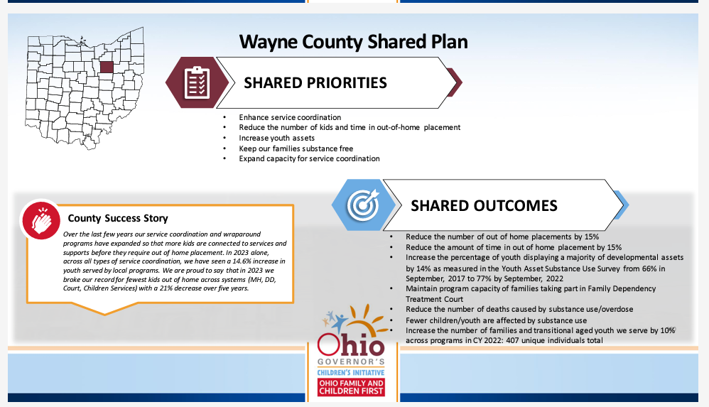

Upcoming Meetings:

Bi-Monthly Council Meetings @ WCPL Resource Grants Management @ CSB
9:35am First Monday of even months (Feb, April, June…) 9:30am Last Tuesday of odd months (Jan, March, May…)

Wayne Early Childhood Coalition Planning Committee/ MCHP Advisory @ Zoom
Quarterly. Location varies. Will convene in the Spring to update the Shared Plan
Contact Esther Hawkins ehawkins@waynefcfc.org Contact Esther Hawkins ehawkins@waynefcfc.org
Executive Committee @ CSB Public Policy Committee @ CSB
Following RGM Last Tuesday of odd months (Jan, March, May…) TBA (as needed)
Contact Rich Owens Richard.Owens@jfs.ohio.gov
Family Advisory Committee @ TBA
TBA Meets around events/projects
Contact Esther Hawkins ehawkins@waynefcfc.org

